
You’re Invited
To Celebrate the
80th Anniversary
of the Fenton
American Legion Post
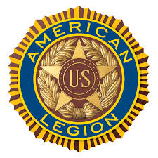

Wednesday, November 19th
FREE Dinner for ALL Veterans
Doors Open at 6:00 PM
Fenton American Legion Post Hall
#2 Gravois Road, Fenton, MO 63026
(Across from Denny Dennis Sporting Goods)

RSVP by Friday, November 14, 2025
at Email: am.leg.post 400@gmail.com
or Leave a Message at 636-343-7330

